For the testing tasks requiring troubleshooting, complete following table.

Note – All the issues reported in the table need to be solved before the delivery.

|  |  |  |  |
| --- | --- | --- | --- |
| Symptoms | Steps taken to trouble shoot | What is the issue | How did you resolve the issue |
| 1. Cannot test and monitor Linux server | Check the package of btop and Iptraf-ng install in the Linux or not. If not, then install it to the Linux server | The btop and Iptraf-ng packages do not install to the Linux server. | Install the package by using command: dnf install btop Iptraf-ng -y |
| 1. Cannot access to Windows sharing files and folder | Check the package of samba smbclient install in the Linux client or not. If not, then install it to the Linux client | The samba smbclient package does not install to the Linux server. | Install the package by using command: dnf install samba smbclient -y |
| 1. Cannot access to Linux sharing files and folders | Check to make sure that the user (thongthao) has created in Linux server or not and give the permission of sharing folder to the user. | The user (thongthao) still not create and give permission to access the sharing files | Create the user by using command useradd thongthao then pdbedit -a thongthao  And give permission to folder share chmod 777 share |

1. Run command btop for monitor Linux Server

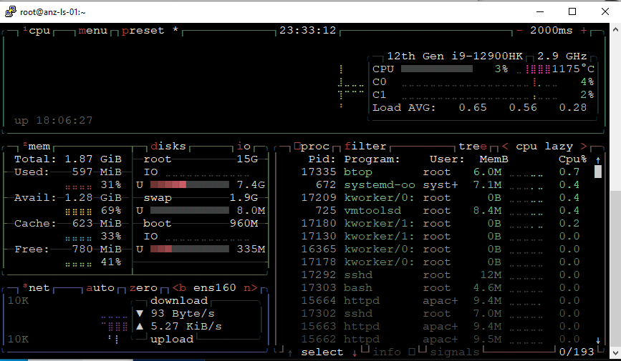

1. Run command Iptraf-ng for monitor Linux network connection

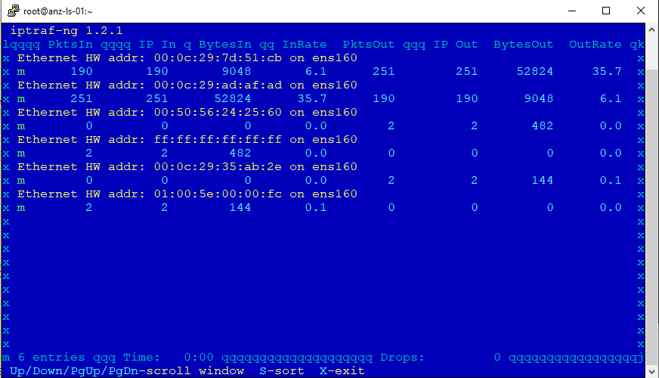

1. Run smbclient to access windows sharing files or folders in Linux

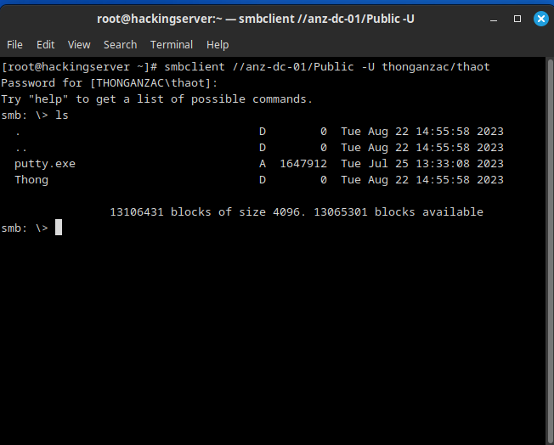

1. Access Linux sharing files or folders in Windows Client.

